E-Commerce Sales Analysis Dashboard Using Power BI

OBSERVATION
- Data Quality:
The raw dataset contained duplicate records and missing values. After cleaning the data, the dataset became more consistent and suitable for further analysis.

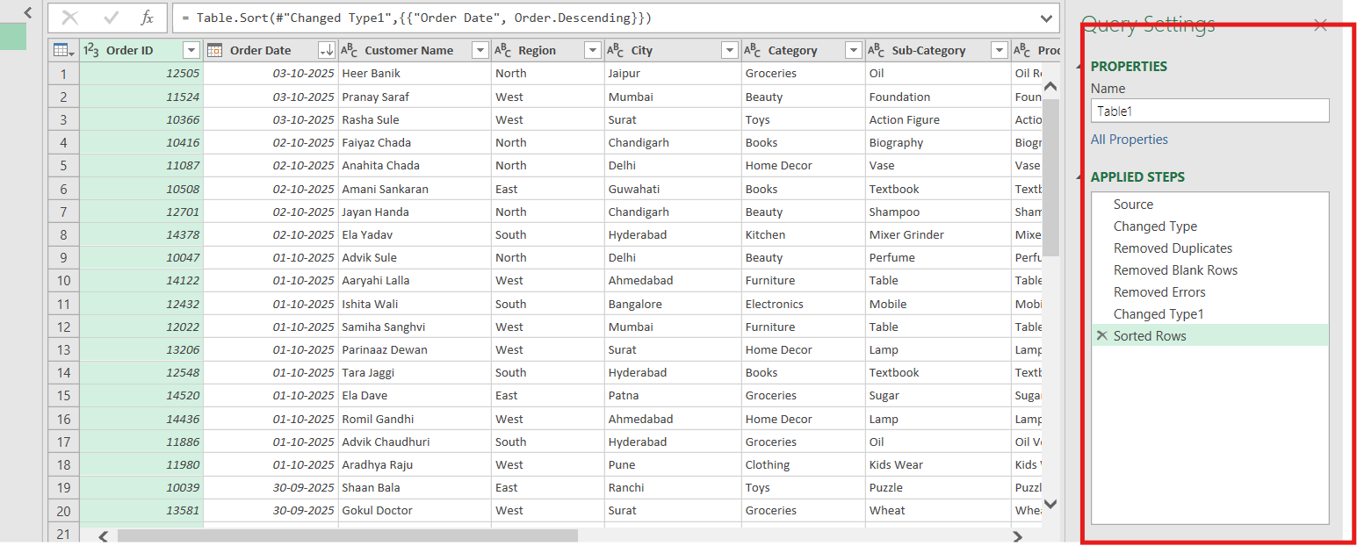

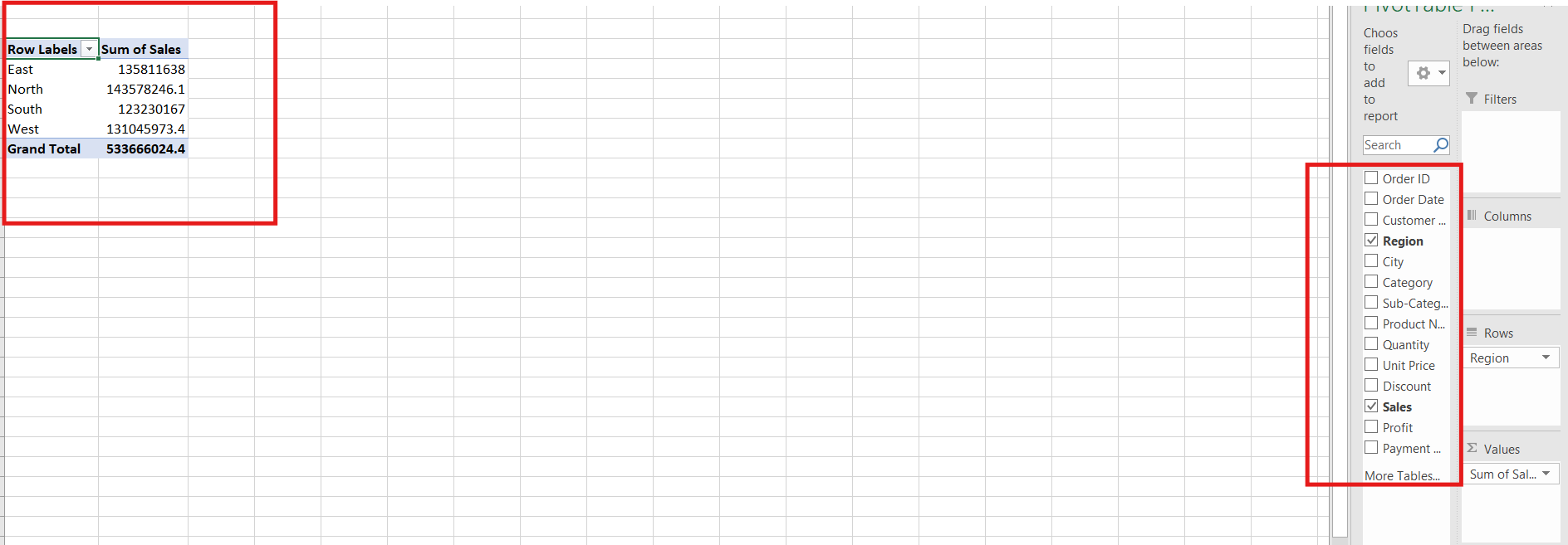

- Data Transformation:
The data was standardized by correcting formats and transforming the required columns. This helped maintain consistency across the dataset and improved the accuracy of analysis.

- Data Distribution:
The analysis helped identify how the records were distributed across different categories and fields. Some categories showed higher values or a greater number of records compared with others.

- Trend Identification:
The Power BI visualizations helped identify important trends and variations in the data. The graphical representation made it easier to compare values and understand changes.

- Category Comparison:
Different categories could be compared using charts and filters. This helped identify which categories performed better and which had relatively lower values.

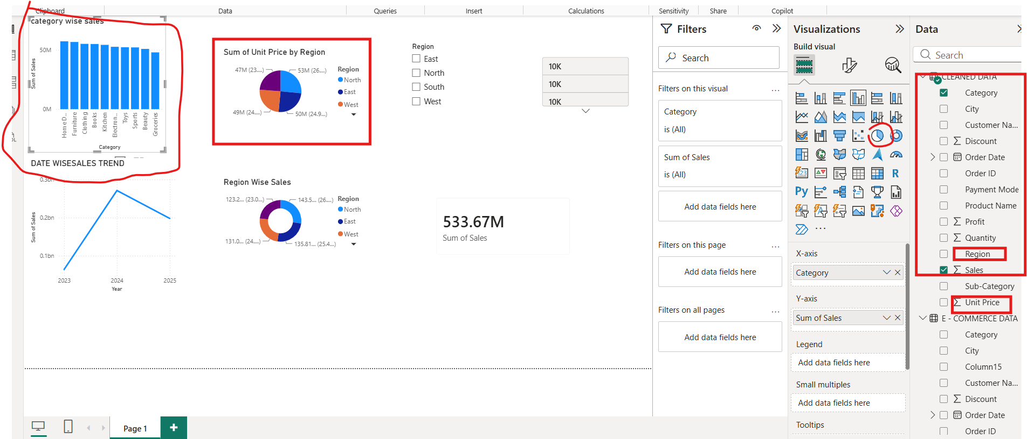
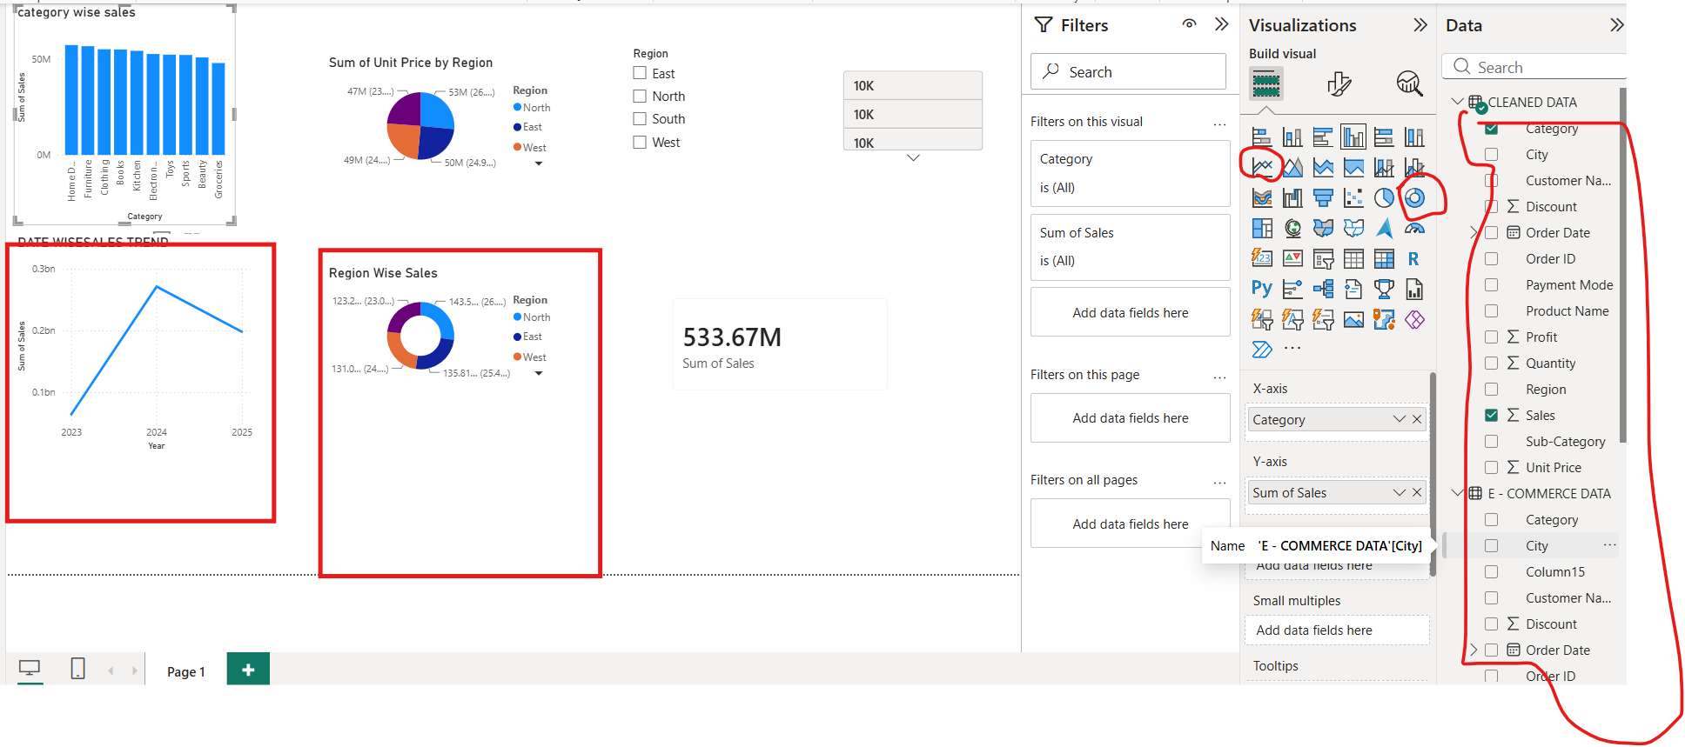
- Interactive Analysis:
Slicers and filters in Power BI allowed the data to be viewed based on different conditions. This made it easier to drill down into specific categories and analyse the data in detail.
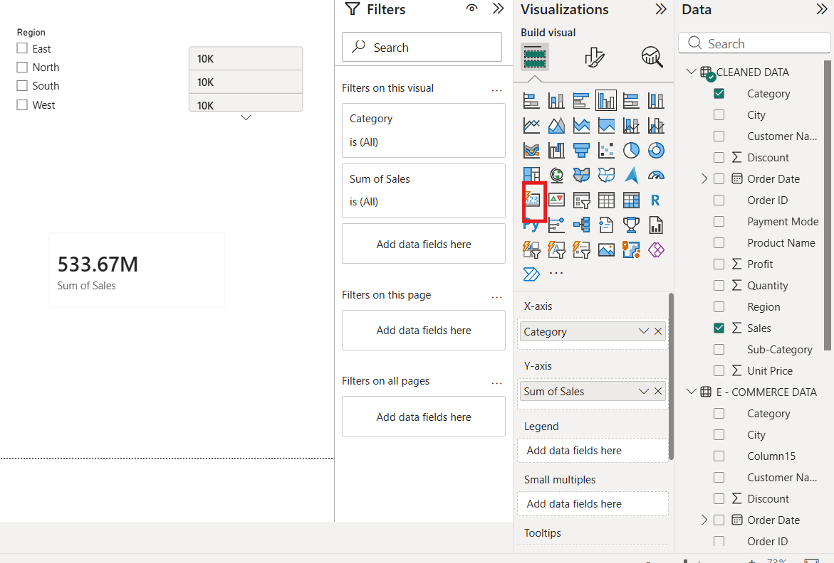

- Key Insight:
The dashboard provides a clear overall view of the dataset and helps users quickly identify important patterns, differences, and areas that require attention.

- Overall Observation:
The combination of Excel for data cleaning and transformation and Power BI for visualization and analysis made the dataset easier to understand and helped convert raw data into meaningful insights.

